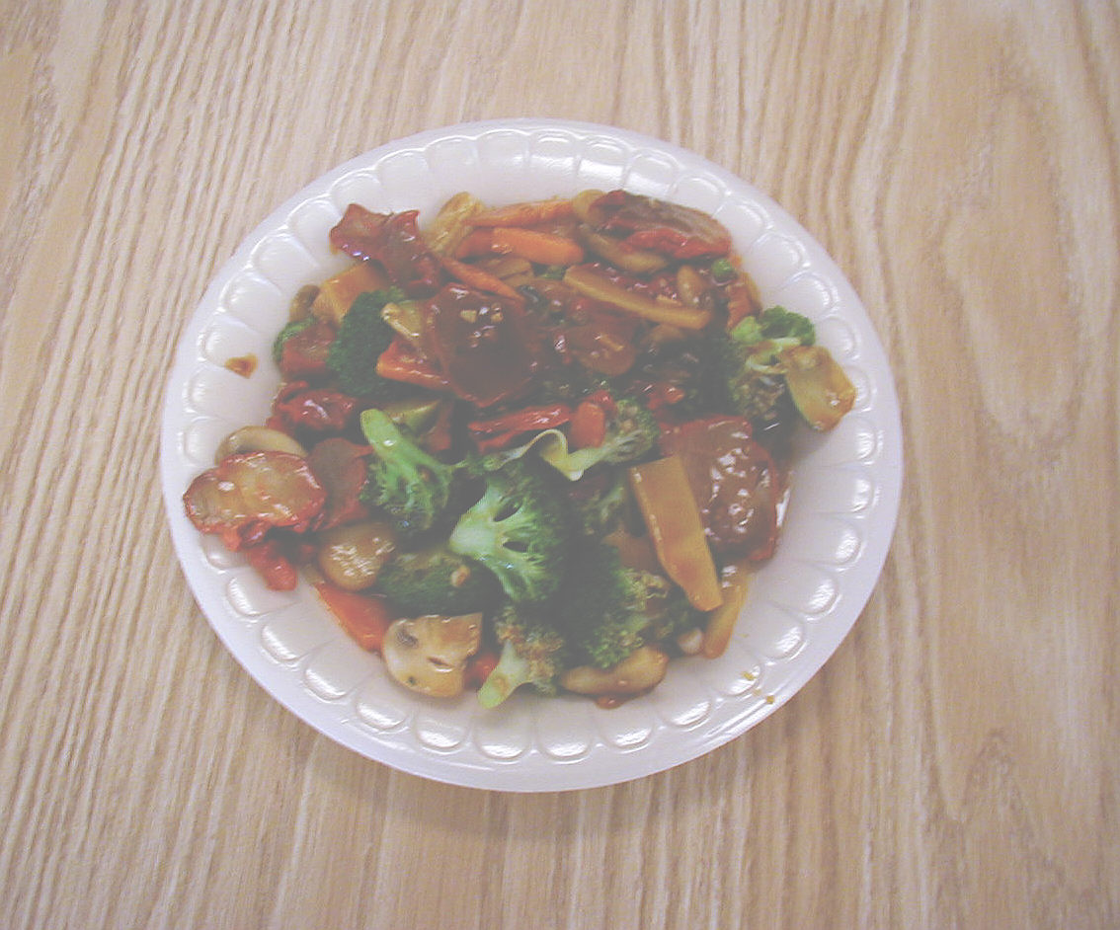
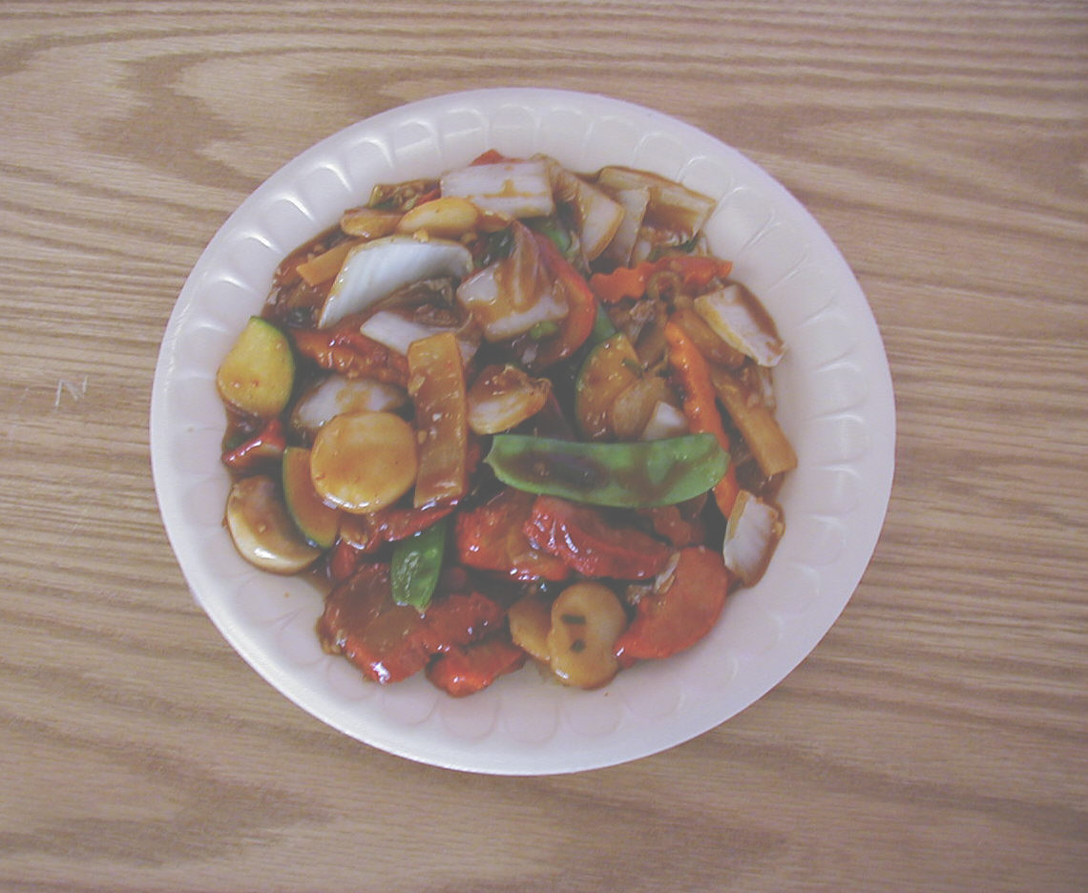
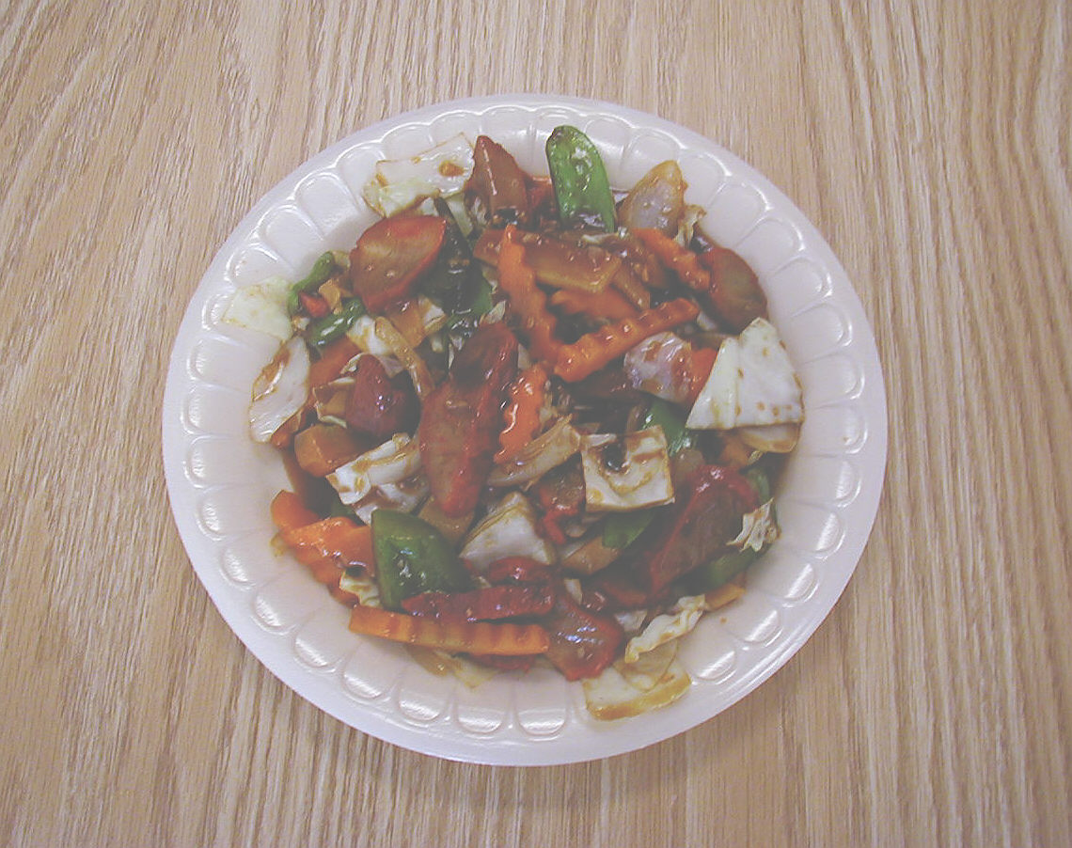
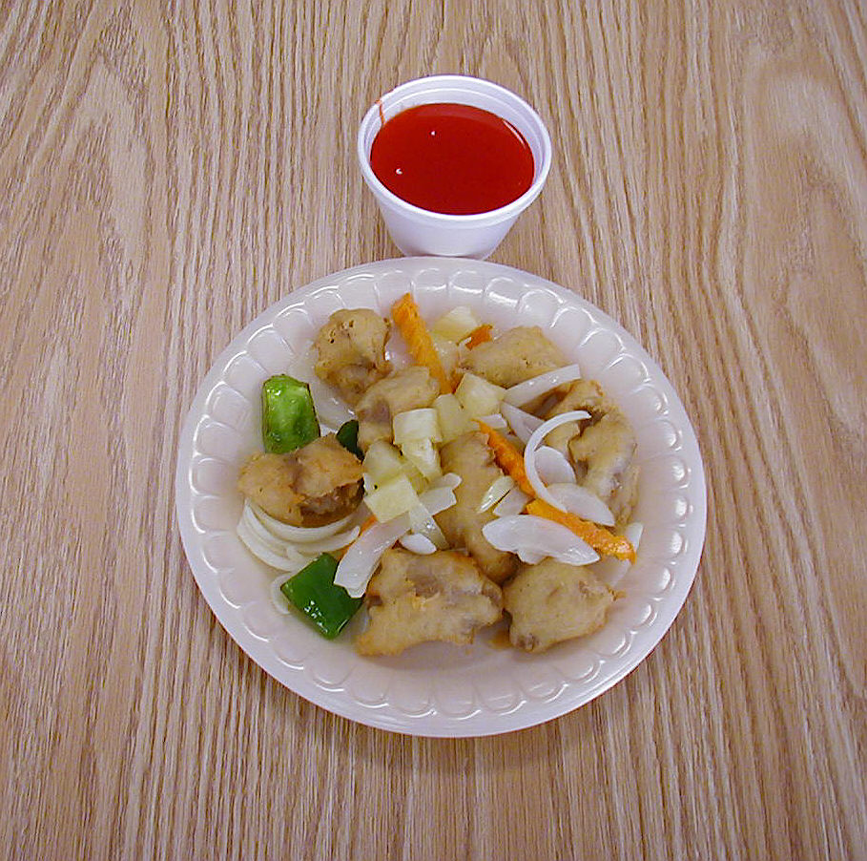
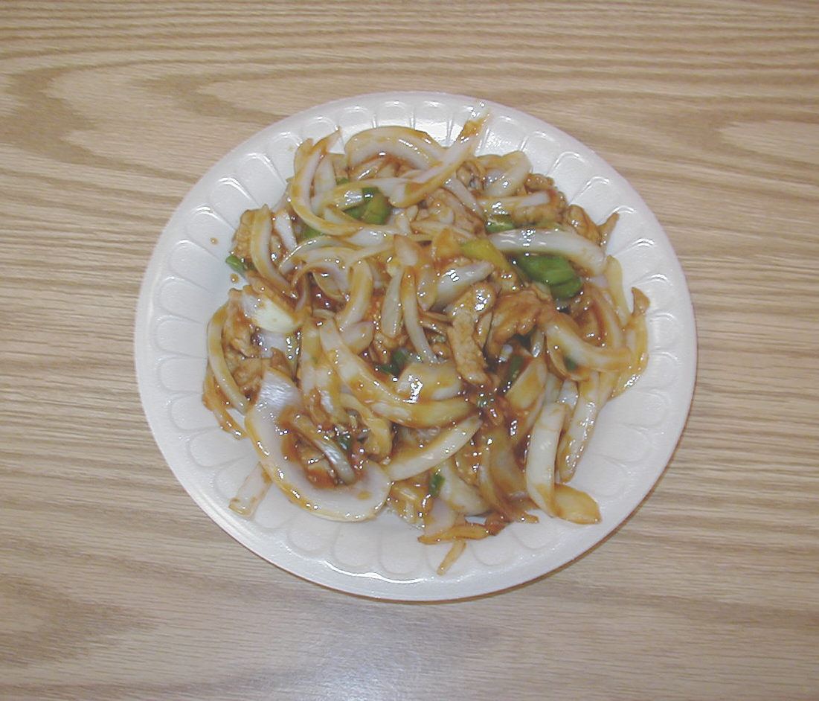
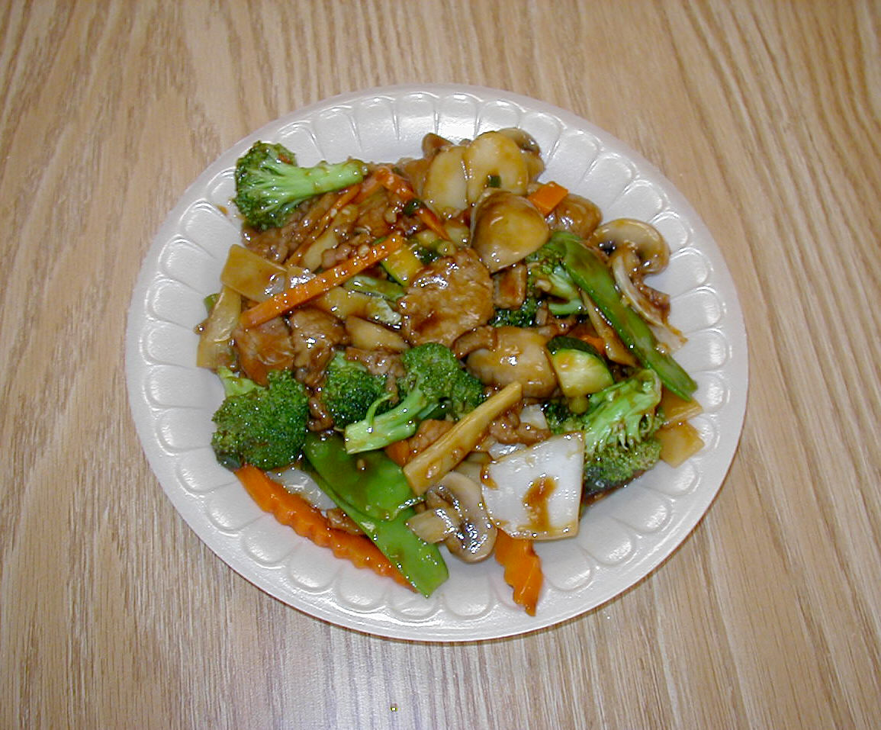
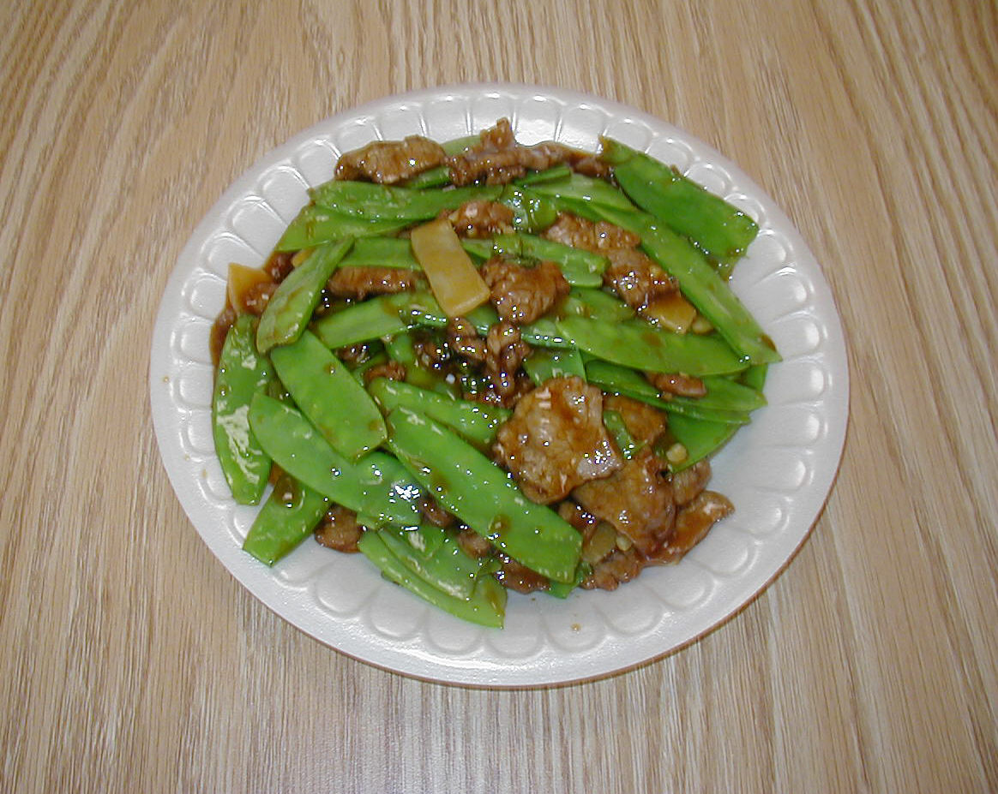
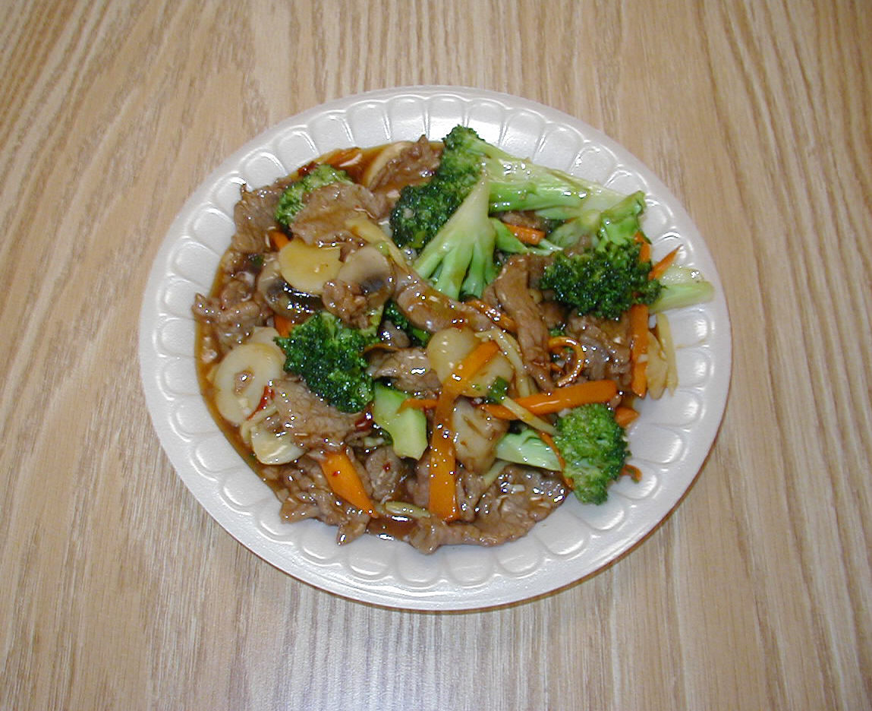
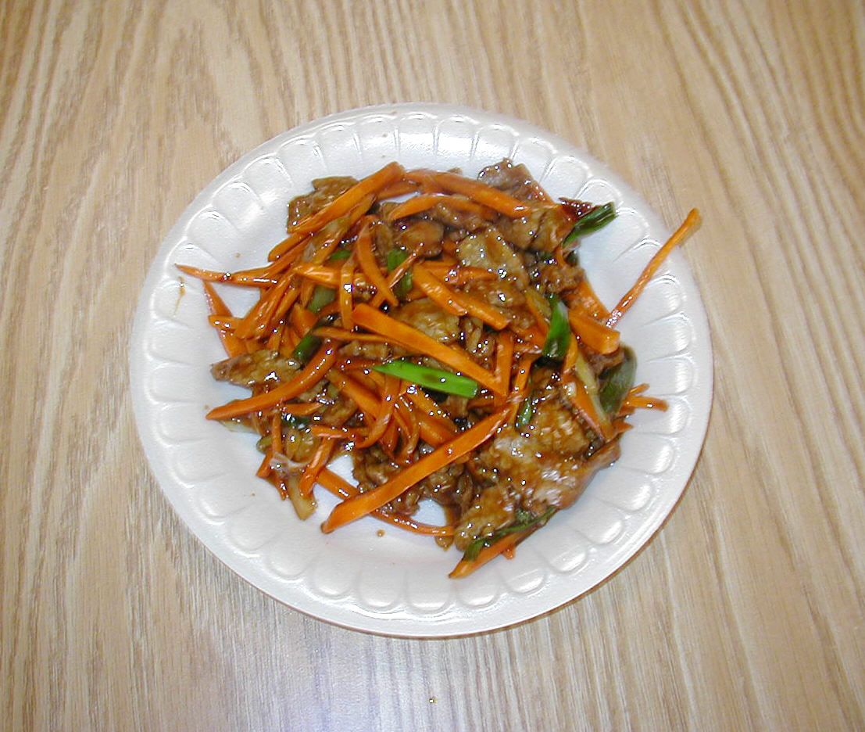
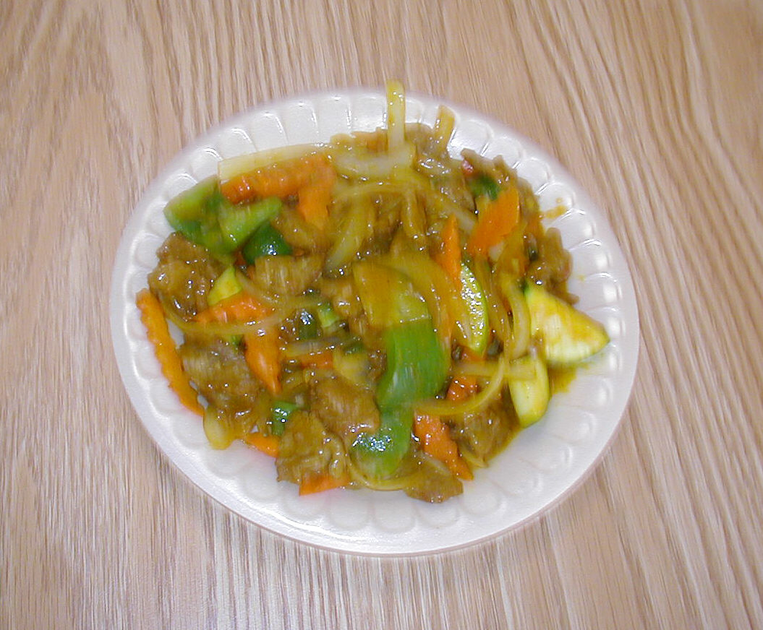
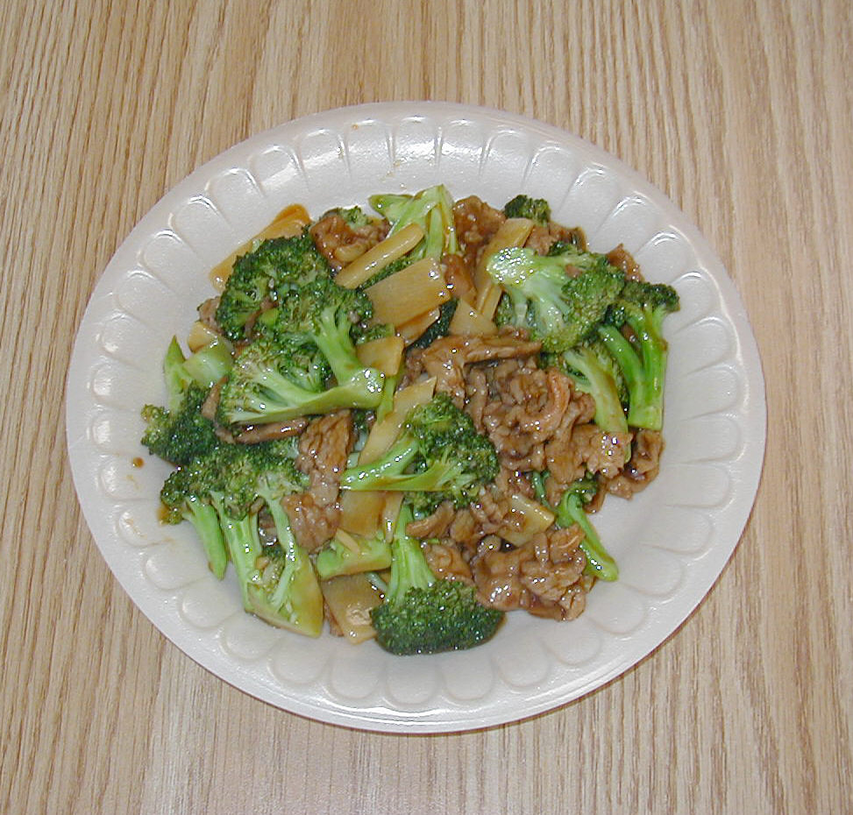
30. & 40. HUNAN PORK OR BEEF
31. & 42. SA-CHA PORK OR BEEF
32. TWICE COOKED PORK
33. SWEET & SOUR PORK
34. BEEF PEPPER STEAK
35. BEEF WITH BROCCOLI

36. BEEF WITH VEGETABLES
37. BEEF WITH SNOW PEAS
38. YU-SHANG BEEF
39. BEEF SZECHUAN STYLE
41. CURRY BEEF

